## User Interfaces

## 3.1. App Icon



Figure 1App Icon

## 3.2. Flash Screen



Figure 2Flash Screen

## 3.4. User Selection Page

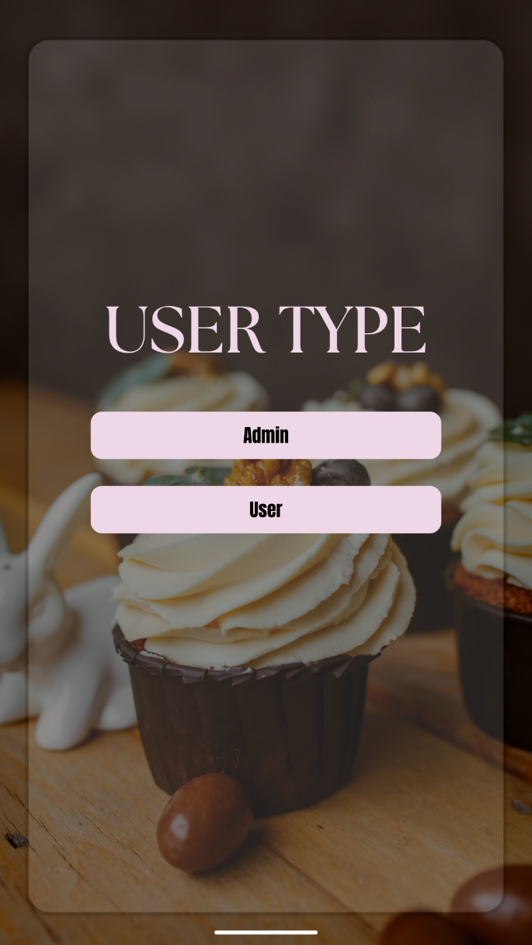

Figure 3User Type

## 3.5. Admin Login

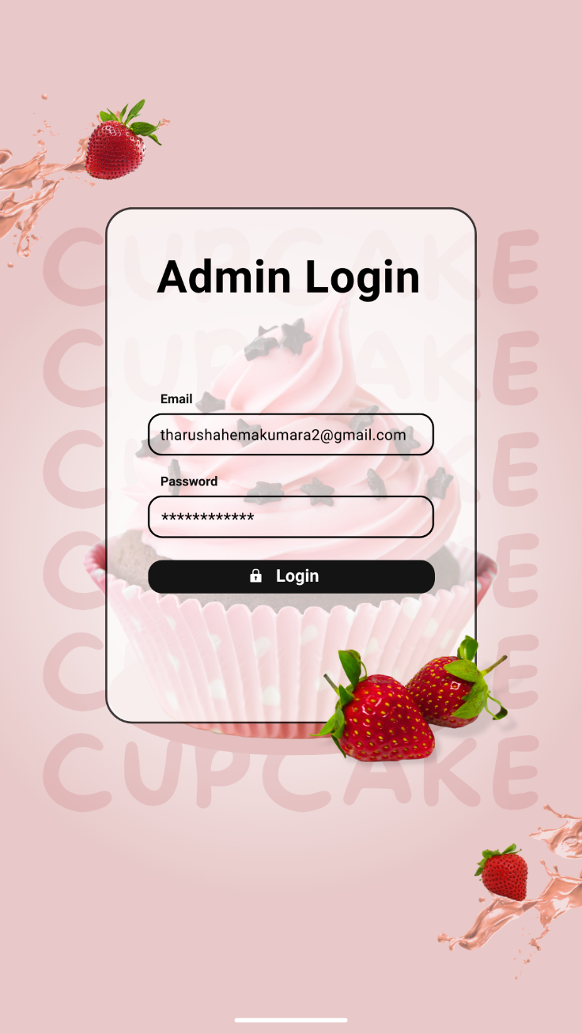

Figure 4Admin Login

## 3.6. User Login

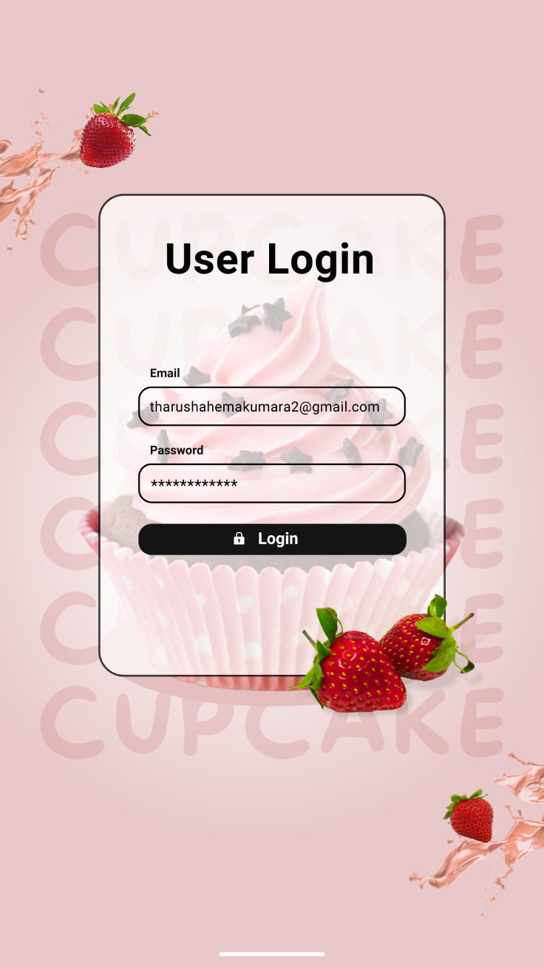

Figure 5User Login

## 3.7. User Signup

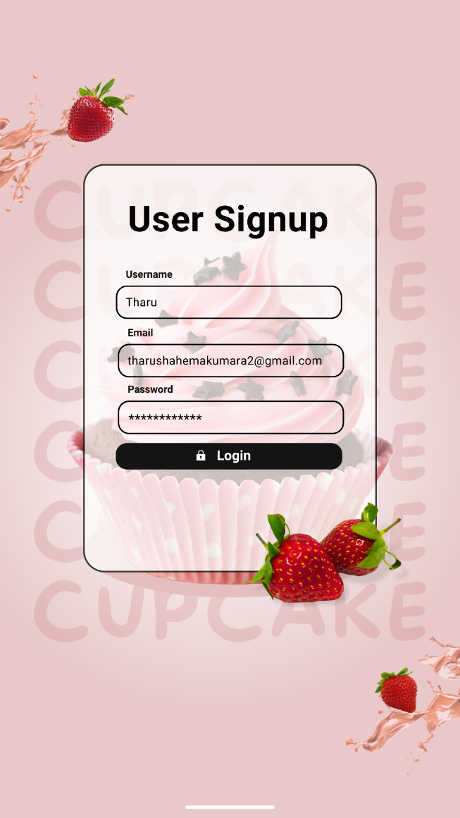

Figure 6User Signup

## 3.8. Category

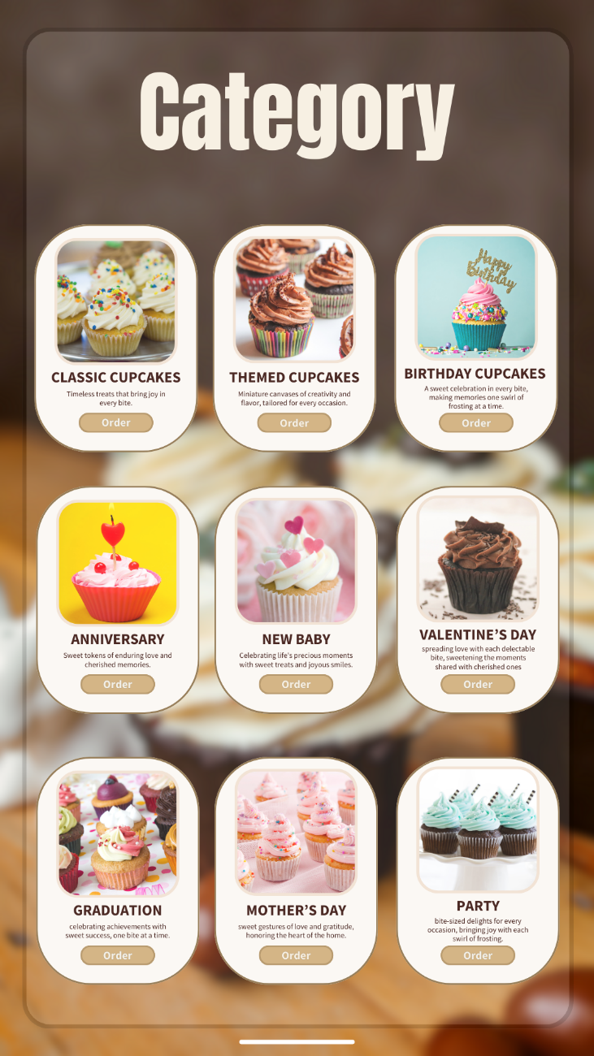

## 3.9. User Home

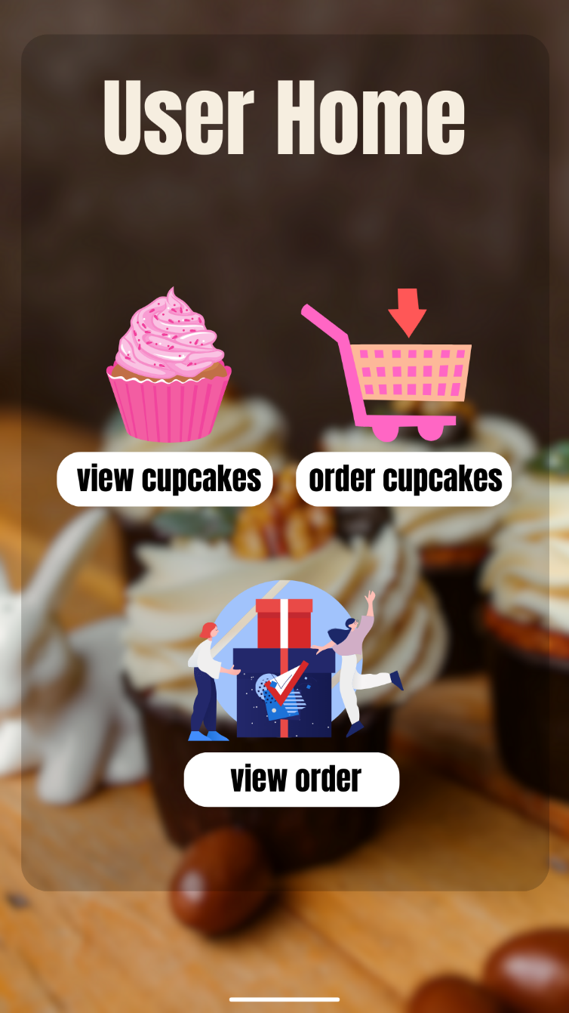

## 3.10. Admin Home

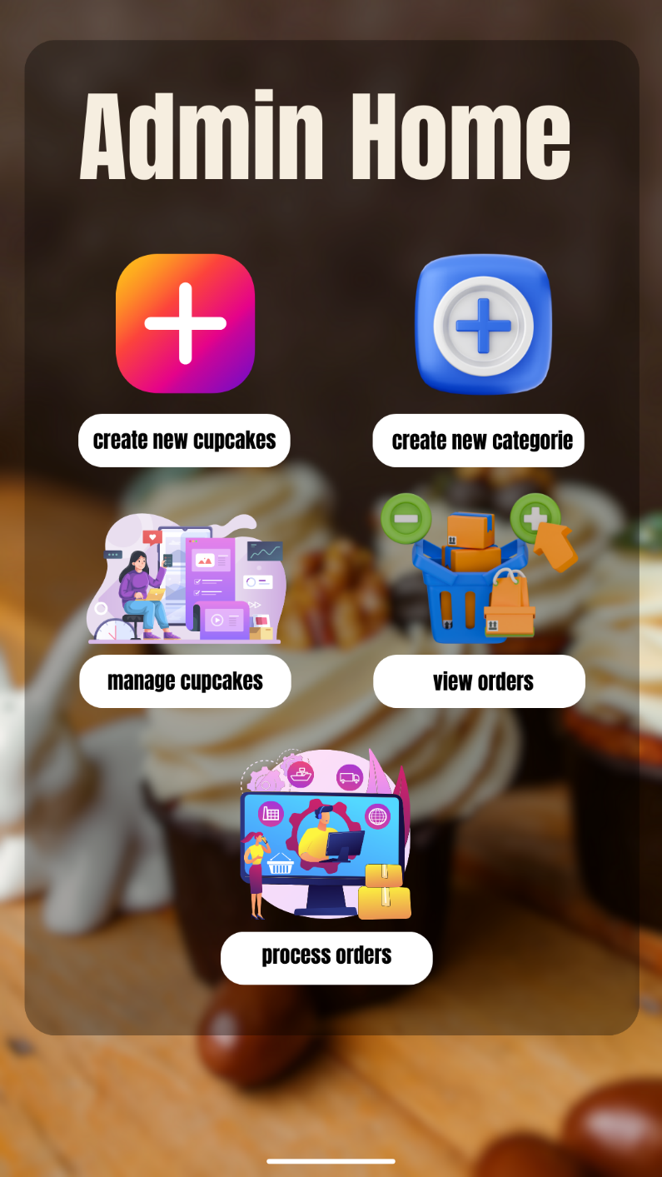

# CHAPTER FOUR

## System Implementation

## 4.1. Login Validation

### 4.1.1. Empty Field

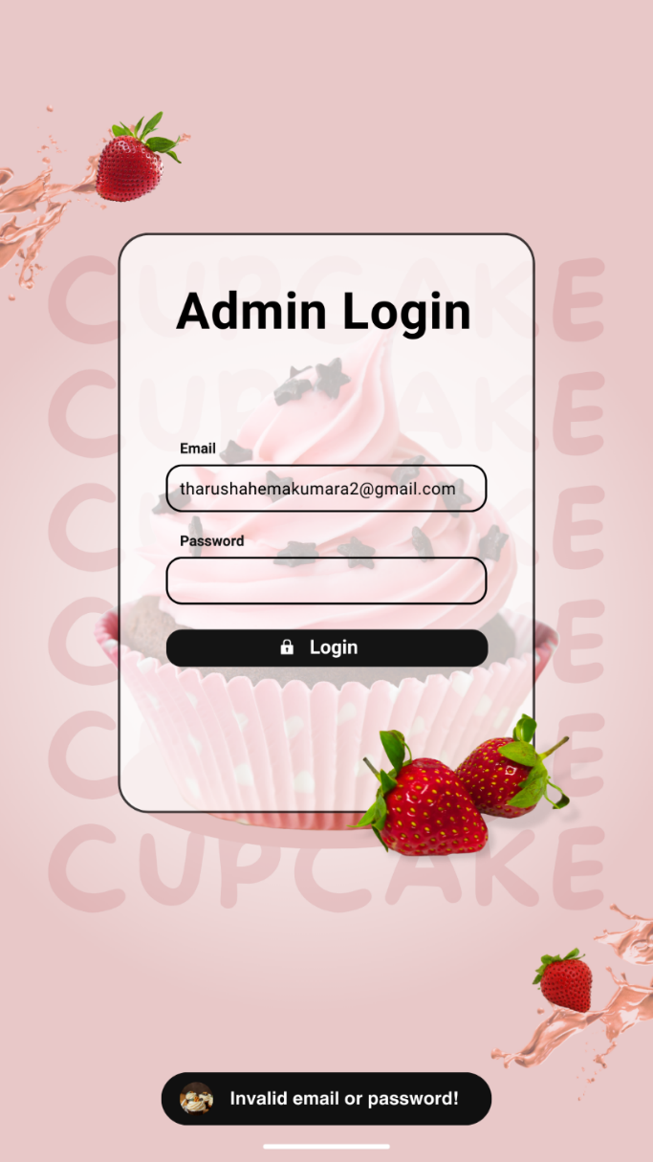

Figure 7 Empty Field

Figure 8 Source Code 1

### 4.1.2. Incorrect Password

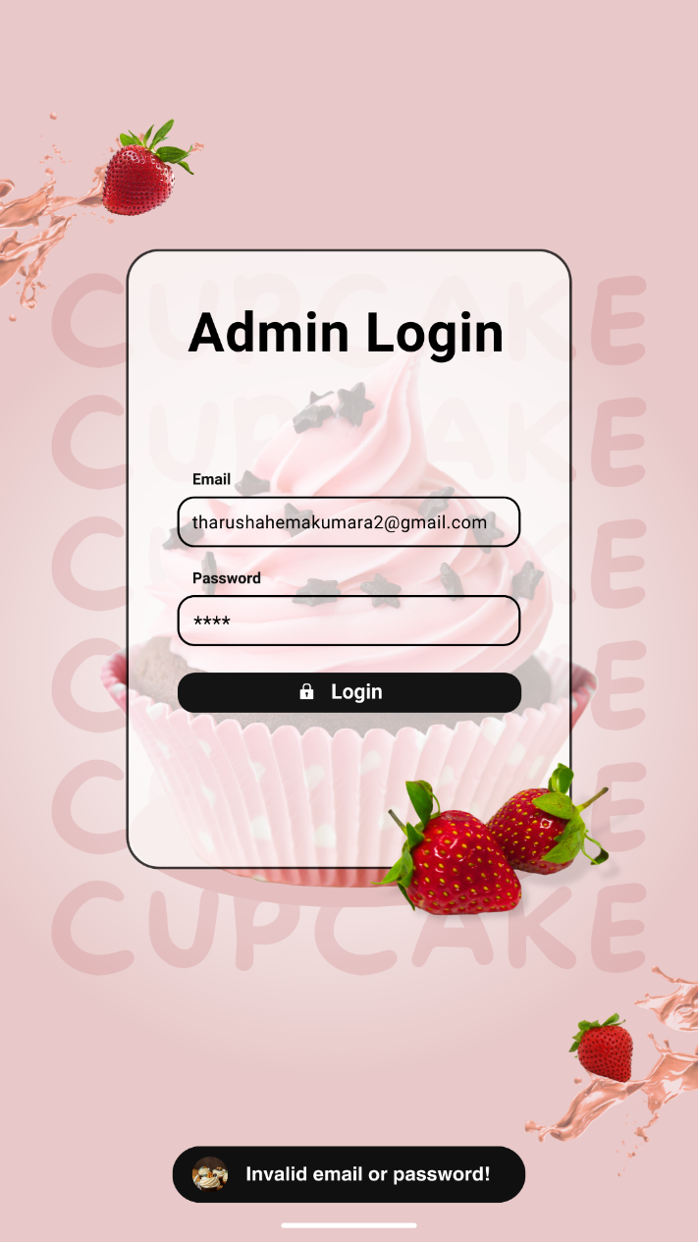

Figure 9 Incorrect Password

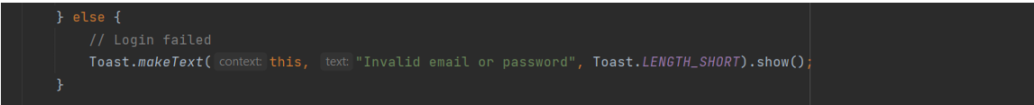

Figure 10 Source Code 2

### 4.1.3. Successfully Logged in

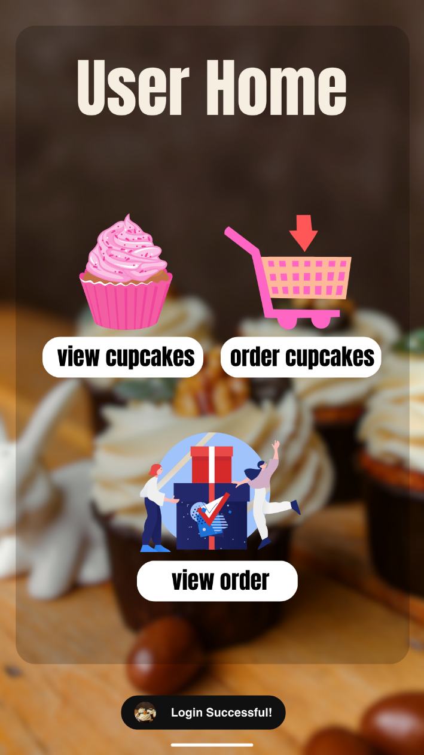

Figure 11Successfully Logged in

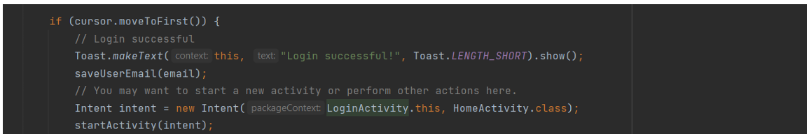

Figure 12Source Code 3

## ser and Technical Documentation

## 6.1. User Documentation

### 6.1.2. User Selection Panel

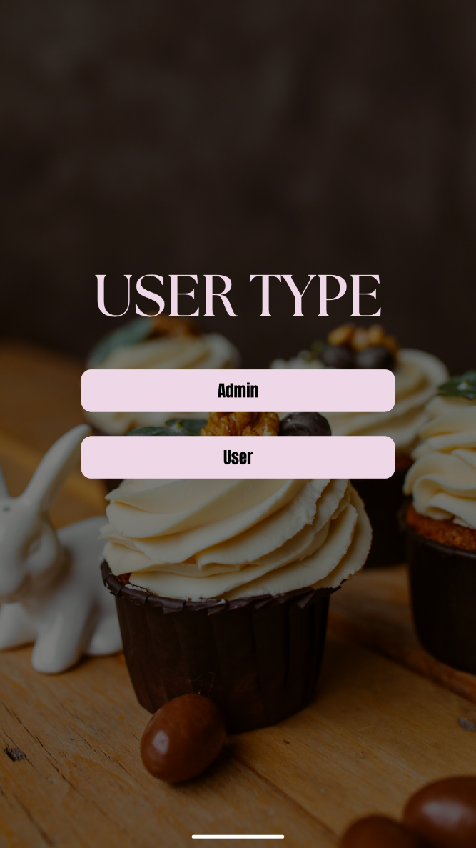

Admin - Click here to move into the admin login panel.

User - Click here to move into the user login panel.

### 6.1.3. Admin Login Panel

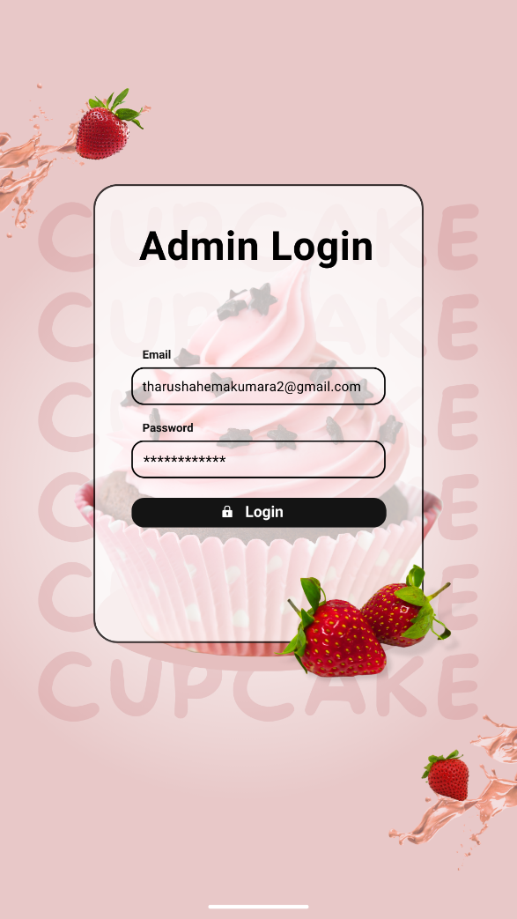

Login - Click here to log into the Admin home panel.

### 6.1.4. User Registration Panel

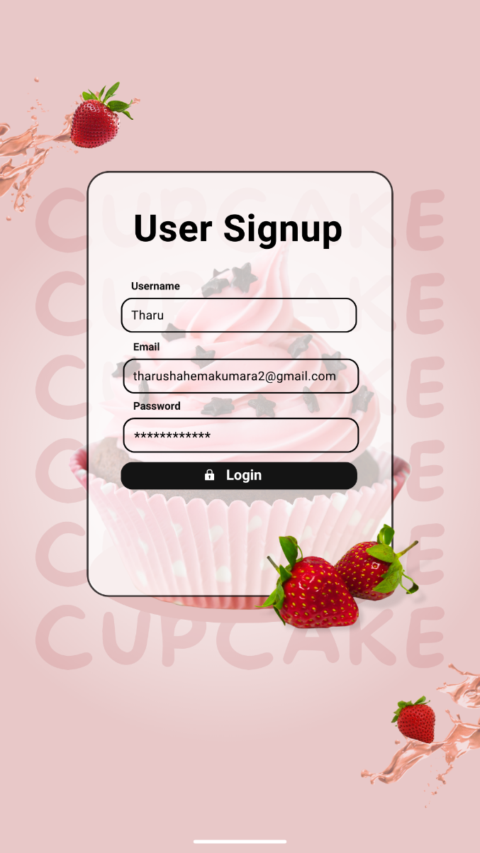

Login - Click here to register owner details and move into the user login panel.

### 6.1.5. User Home Panel

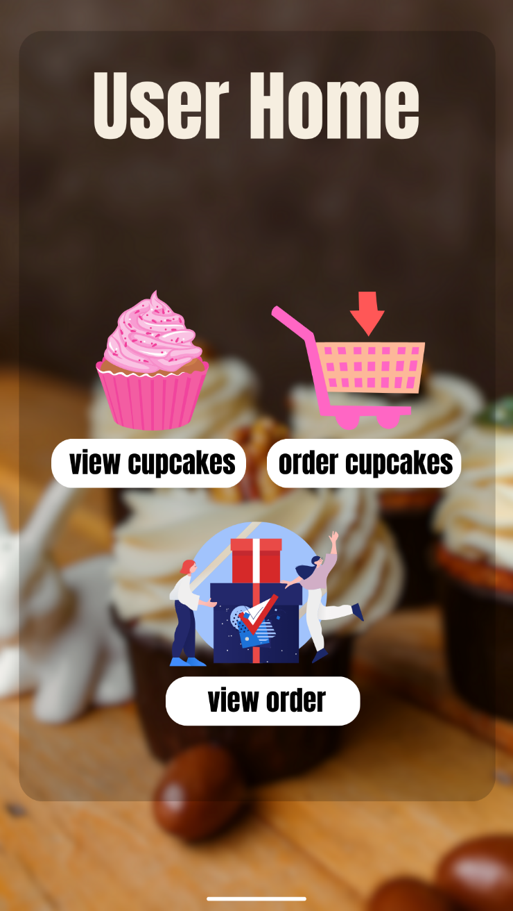

**View Cupcakes** - Click to view the category.

**Oder Cupcake** - Click to order cupcakes in the category.

**View Oder Cupcake** – Click to the View Oder Cupcake.

### 6.1.5. Admin Home Panel

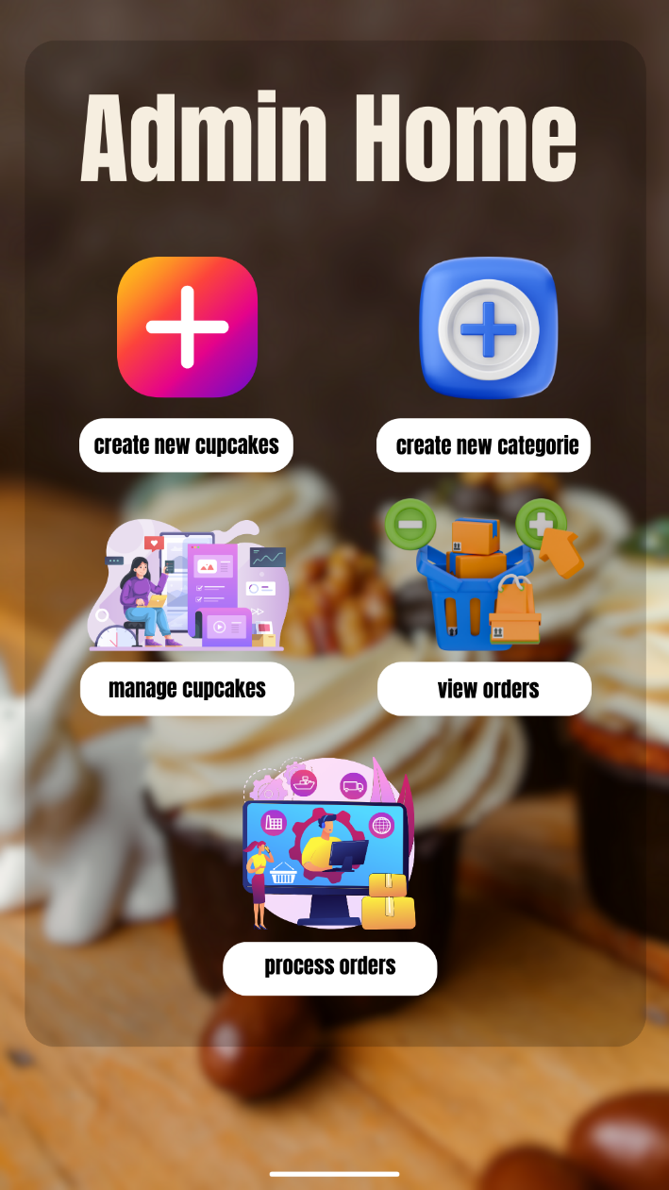

**Create a new cupcake** - Click to create a new cupcake.

**Create a new Cupcake category** - Click to create a new cupcake category.

**Manage cupcakes** – click to manage cupcakes.

**View orders** – click to view order cupcakes.

**Process order** – click to process order.

**User Documentation**

**1. Introduction to The Cupcake Factory App** Welcome to The Cupcake Factory App! Our mobile application is designed to bring our delicious cupcakes closer to you, allowing you to browse, customize, and order your favorite treats right from your device.

**2. Getting Started**

* **Installation**: Download the app from the Google Play Store or Apple App Store. Install it on your device and open it to get started.
* **Registration**: To place an order, you'll need to create an account. Tap on the 'Sign Up' button on the home screen, fill in the necessary details, and follow the prompts to complete the registration.

**3. Placing an Order**

* **Browsing Cupcakes**: Once logged in, explore our variety of cupcakes by navigating through the categories. Each category showcases a selection of themed cupcakes.
* **Selecting and Customizing Your Cupcake**: Tap on your chosen cupcake to view details. You can customize it based on available options (size, flavor, frosting, etc.). Click 'Add to Cart' once you're satisfied with your selections.
* **Checking Out**: With items in your cart, press the 'Checkout' button. Confirm your order details, enter your delivery address, and choose your payment method. Finalize your order by tapping 'Place Order'.

**4. Managing Your Account**

* **Viewing Order History**: Access your past orders and their statuses by tapping on the 'Order History' section.
* **Updating Account Information**: Update your personal information, password, or address under the 'My Account' section.

**Technical Documentation**

**1. System Overview** The Cupcake Factory App is developed for both Android and iOS platforms, utilizing React Native for cross-platform compatibility. The app integrates with a backend server for data management, order processing, and user authentication.

**2. Architecture**

* **Frontend**: Developed using React Native, the frontend provides a user-friendly interface for customers to interact with the app.
* **Backend**: The server, built with Node.js and Express, handles API requests, processes orders, manages user data, and interacts with the database.
* **Database**: MongoDB is used for storing user profiles, order details, and cupcake information.

**3. Key Functionalities**

* **User Authentication**: Implemented with JWT for secure login and registration processes.
* **Cupcake Browsing and Ordering**: Users can browse through categories, select cupcakes, customize them, and place orders.
* **Order Management**: The backend processes orders, updates statuses, and manages inventory.

**4. Development Environment**

* **Android Studio and Xcode**: For testing and debugging the app on Android and iOS devices.
* **Version Control**: Git is used for source code management, ensuring team collaboration and code integrity.

**5. Deployment**

* **Continuous Integration/Continuous Deployment (CI/CD)**: Automated pipelines are set up for testing and deploying the app to the respective app stores.

**6. Maintenance and Support**

* **Monitoring and Updates**: Regular monitoring for app performance and user feedback is conducted to plan and roll out necessary updates.

**Appendices**

* **Screenshots**: Include screenshots of the app's key screens along with annotations for better understanding.
* **Code Snippets**: Provide examples of critical code sections, explaining the logic and functionality.

## 6.2. Technical Documentation

### 6.2.1. Minimum system requirement for the mobile application

**Android:**

* **Operating System**: Android 8.0 (Oreo) or later.
* **Processor**: Quad-core 1.4 GHz or higher.
* **RAM**: Minimum of 2 GB.
* **Storage**: At least 100 MB of free space for installation, additional space for data caching and updates.
* **Screen Resolution**: 480x800 pixels or higher.
* **Network**: Reliable internet connection (Wi-Fi, 3G, or 4G).
* **Google Play Services**: Must be installed and up to date.

**iOS:**

* **Operating System**: iOS 12.0 or later.
* **Device Compatibility**: iPhone 6s or later, iPad Air 2 or later, and iPod touch (7th generation) or later.
* **Processor**: A9 chip or later.
* **RAM**: Minimum of 2 GB.
* **Storage**: At least 100 MB of free space for installation, additional space for data caching and updates.
* **Screen Resolution**: 1334x750 pixels or higher for iPhones, 2048x1536 pixels or higher for iPads.
* **Network**: Reliable internet connection (Wi-Fi, 3G, or 4G).

These requirements are set to ensure that The Cupcake Factory app runs smoothly, providing a seamless user experience while maintaining a broad compatibility range with a variety of devices. Users should verify their device specifications against these requirements before downloading and installing the app to avoid any compatibility issues.